School : ___________________ Primary school Test
Name : _____________________ Subject : English
Class : 2/_ Date : _______________

Marks | Remark

I.Listening.
Part 1. Listen and choose the correct answer. (Nghe và chọn câu đúng) (2 points)
0. | A. It’s raining. | B. It’s snowing. | C. It’s sunny.
1. | A. I’m wet. | B. I’m hot. | C. I’m cold.
2. | A. I’m hungry. | B. I’m sad. | C. I’m happy.
3. | A. Noodles. | B. Soup. | C. Chicken.
4. | A. That’s my pillow. | B. That’s my bear. | C. That’s my blanket.
5. | A. Bear. | B. Pillow. | C. Blanket.
6. | A. Red light. Stop! | B. Green light. Go! | C. Yellow light. Go slow!
7. | A. He’s a farmer. | B. She’s a doctor. | C. She’s a police officer.
8. | A. Ice cream. | B. Candy. | C. Chips.
Part 2. Listen and write. (Nghe và viết từ đúng vào chỗ trống) (0,5 point)
raining | hungry | Be quiet!

0. | I’m hungry . Have some chicken. Mmm. It’s good.
1. | Hurry up! It’s . I’m wet.
2. | That’s my pillow. No! It’s my pillow. Shh! .

II. Choose the word with the correct spelling. (Chọn từ đúng chính tả) (2 points)
0. |  | Dotor  Doctor  Docton
1. | Chicken  Chiken  Chickel |  |  | 2.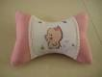 | Pillou  Pillow  Pilow
 | 3. | Chipp  Ships  Chips | 4. 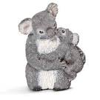 | Baer  Bear  Brear
5. 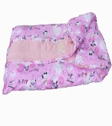 | Blanket  Banket  Blamket |  |  | 6. | Codl  Cool  Cold
 | 7. | Snowimg  Snoving  Snowing | 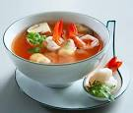8. | Suop  Soup  Soap

III. Odd one out. (Tìm từ khác loại) (2 points)
A | B | C | D
0. chicken | soup | blanket | noodles
1.hot | pillow | cold | wet
2.pillow | soup | bear | blanket
3.raining | sunny | snowing | chicken
4.red light | bear | green light | yellow light
5.farmer | doctor | candy | police officer
6.candy | police officer | ice cream | chips
7.pillow | bear | blanket | wet
8.teacher | chips | doctor | farmer

IV. Complete. (Hoàn thành mỗi từ sau bằng cách thêm 1 chữ cái) (1,5 points)
0. |  | ra i ning | 4. |  | w t
1. |  | h t | 5. |  | no dles
2. |  | ca dy | 6. |  | po ice officer
3. |  | s nny | 7. |  | ic cream

V. Read and choose the correct response. (Đọc và chọn câu phản hồi đúng) (2 points)
0.Hurry up! | =>A.I’m wet. | B.It’s raining. | C.It’s sunny.
1.I’m hungry | =>A.I’m hot. | B.I’m cold. | C.Have some chicken.
2.That’s my pillow | =>A.Go! | B.No, It’s my pillow. | C.It’s sunny.
3.Hurry up! It’s raining | =>A.I’m wet. | B.No! not today. | C.Go!
4.Red light. | =>A.Go! | B.I’m cold. | C.Stop!
5.I want candy. | =>A.No! not today. | B. No, It’s my bear. | C. No, It’s my blanket.
6.Green light. | =>A.It’s snowing. | B.Go! | C.I’m cold.
7.I’m hungry.Have some chicken. | =>A.Mmm.It’s bad | B. No! not today. | C. Mmm.It’s good.
8.That’s my bear. No, It’s my bear. | =>A.Shh! Be quiet! | B.Stop! | C.Go!

THE END

School : ___________________ Primary school Test
Name : _____________________ Subject : English
Class : 2/_ Date : _______________

Marks | Remark

I. Complete the sentences : ( 3 points )
1. She’s a……………………… 2. She’s a………………………

- He’s a……………………… 4. She’s a………………………

5. I’m hungry. 6. I’m hungry.
Have some……………… Have some………………
Mmm. It’s good. Mmm. It’s good.

II. Uncramble and match : ( 2 points )
ebar ……………………
spou …………………… 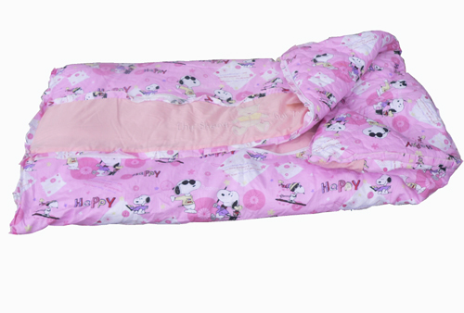
llowpi ……………………
ketblan …………………..

III. Match : ( 3 points )
sunny
raining
snowing
wet
cold
hot

VI. Look and write (2 points) 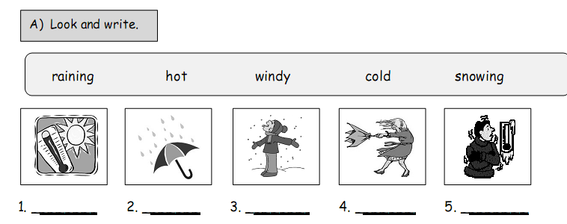

THE END

School : ……………………….. Primary school Test
Name : _____________________ Subject : English
Class : 2/_ Date : _______________

Marks | Remark

I, Khoanh tròn các từ phù hợp với tranh(2 điểm).
4.
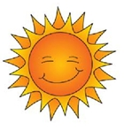
sunny
snowing
raining

1. 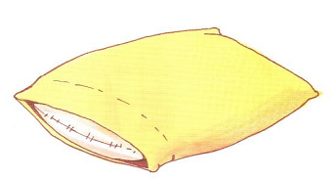
pillow
blanket
bear

2 . 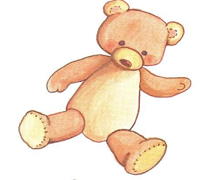
mouse
monkey
bear

3.
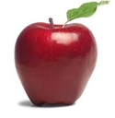
apple
mango
orange

II, Dịch sang Tiếng Anh (2,5 điểm).
- Mình muốn kẹo. ……………………………………………
- Cô ấy là một cảnh sát. ……………………………………………
- Ông ấy là một nông dân. ……………………………………………
- Mình thì đói bụng. …………………………………………….
- Đó là cái gối của mình. ……………………………………………

III, Điền chữ còn thiếu vào mỗi từ sau (1,5 điểm).

- r.……. 2. ch…. . 3.s………

4.c.………. 5. s…. … 6. h………..

IV. Sắp xếp lại các chữ cái để tạo được từ phù hợp với mỗi tranh sau(4 điểm).
1. faerrm-> .................................... 2. hcretea->..........................................

3. noodesl->........................................ 4. balnetk -> .......................................

5. llopiw->........................................ 6. supo -> .......................................


7. polci officre->..................................... 8. tordoc-> .......................................

“ Good luck to you ”

“ the end ”

